01-Sept-21

This archive contains a firmware dump, Ver. -1D, from the Ballantine Labs model 6127A Programmable Oscilloscope Calibrator. File names and chip details as follows, the files are in BIN and HEX format. 2732A are Fujitsu MBM2732A-45.

Processor Board A30
- U2_10398-1D_MBM2732A-45.BIN
- U2_10398-1D_MBM2732A-45.HEX
- U3_10399-1D_MBM2732A-45.BIN
- U3_10399-1D_MBM2732A-45.HEX
- U4_10400-1D_MBM2732A-45.BIN
- U4_10400-1D_MBM2732A-45.HEX

The three 2732's are located on the CPU board, in the center cage. The A26 U4 bipolar PROM is located on the A26 VOLTS board, left side (with the instrument facing you), directly in front of the foremost card edge connector.

Volt Interconnect Board A26 Relay control
- U4_bal6127b-24-10402-1c.bin

Note:
The file included is from the 6127B (bal6127b-24-10402-1c-u4.bin). The truth table and the device type are the same for the 6127A and 6127B as shown below. The 6127A uses a National Semiconductor DM74S188N p/n 24-10352-1, the 6127B has a Signetics 82S23 p/n 24-10402-1c. On the schematic of the 6127B U4 is labelled 24-10352-1.

Location of U4

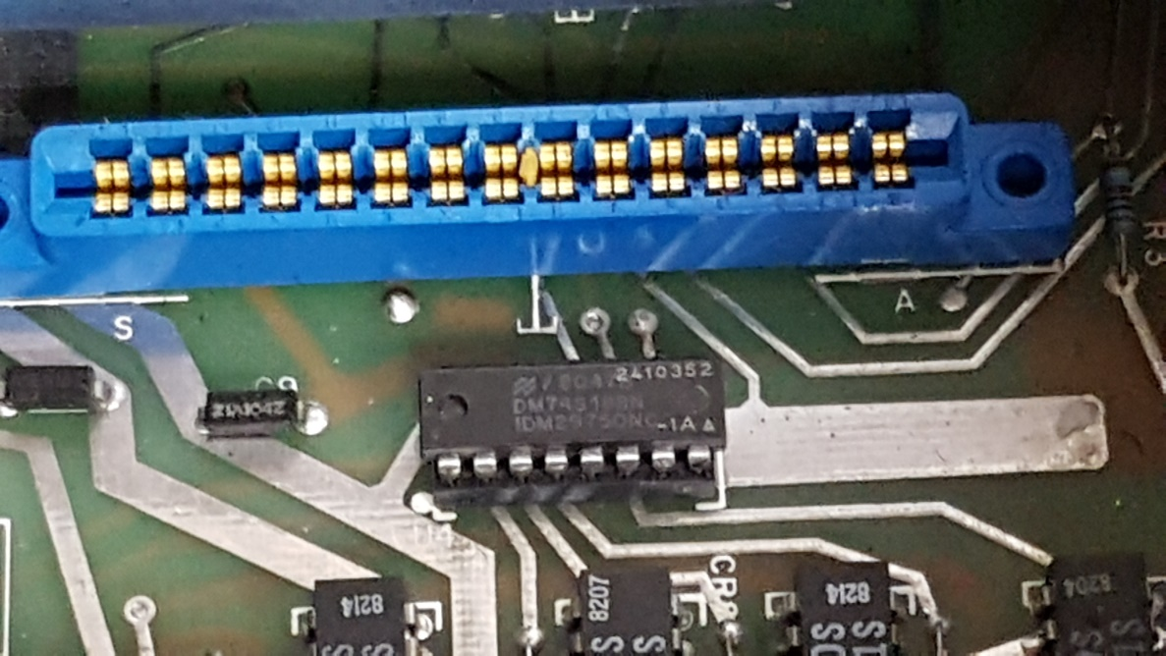
The service manual says that U4 serves as a relay decoder/driver, accepting a binary input and selecting which relay to trip as a result, to program output volts or current.

Ballantine 6127A

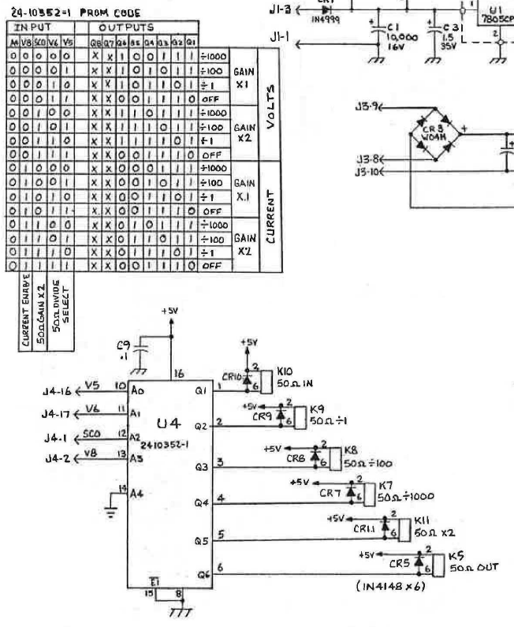

Ballantine 6127B

