See Reply #15
https://www.eevblog.com/forum/testgear/hp-agilent-e4433b-esg-d-series-signal-generator-250khz-4-0ghz/msg3240634/#msg3240634
Google the generator and use it as shown.
Hint: Search for "lmcryptgui.rar"

HP ESA Spectrum Analyser
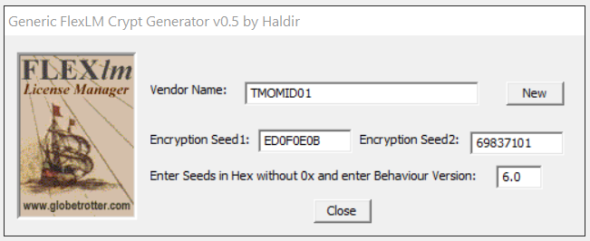

Vendor name: TMOMID01
Seed1: ED0F0E0B
Seed2: 69837101
Behaviour: 6.0
You need to create the license file yourself, add in bogus keys, then run the program from a cmd window and add the name of the license file after it.

The licenses should have this format:
FEATURE 202 TMOMID01 1.0 permanent uncounted 0123456789AB HOSTID=E1234567

Where:

FEATURE: Option number ie 1D5 is Narrow RBW
License key: 0123456789AB
HOSTID: E1234567

Such as: lmcryptagilent license.lic

It will then calculate the proper keys and add them to the license.lic file

I believe you can just drag the file to the exe or something as well. I did it from cmd window.

Example with E4402B HOSTID: 1301531D:

License.lic is created with Notepad.
Body of file is:
FEATURE 1DR TMOMID01 1.0 permanent uncounted 0123456789AB HOSTID=1301531D
Where 0123456789AB is the bogus license key

Save the file and close Notepad

In a CMD window run:

lmcryptTMOMID01 license.lic
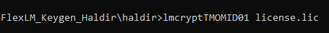

Reopen license.lic in Notepad:
FEATURE 1DR TMOMID01 1.0 permanent uncounted FB2A3EE02016 \
HOSTID=1301531d
Where the license for 1DR option is FB2A3EE02016

For verification E4402B HOSTID: 1301531D has one option 1D5 with a license of D86C61035EF7

Doing the above procedure yields:
FEATURE 1D5 TMOMID01 1.0 permanent uncounted D86C61035EF7 \
HOSTID=1301531d

HP 16900

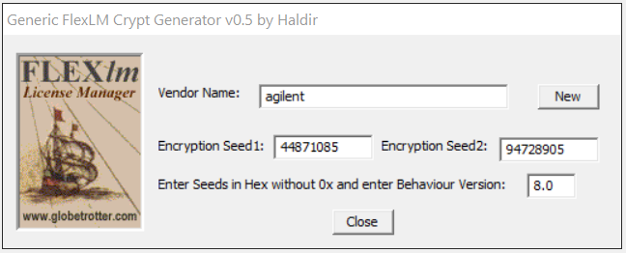

Agilent N1996A spectrum analyzer.
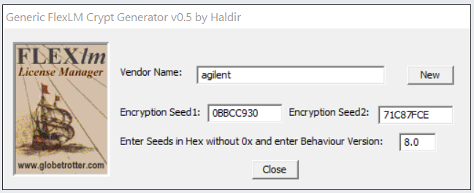

Re: Agilent N1996A software unlock
« Reply #15 on: January 14, 2021, 08:26:51 pm »
- Say Thanks
- Reply
- Quote
Actually, I just typed in what I saw in the screenshot a few posts back. So, there's a FLEXlm keygen? My host ID is 307929DE. Most of the options are enabled. I just figured it fully option it out. The only locked options remaining are 271 Spectrogram, AFM AM/FM Tune and Listen, and N8996A-1FP AM/FM Modulation Analyzer. There's also 330-380 but I think those are installable programs that Agilent/Keysight used to offer.

Re: Agilent N1996A software unlock
« Reply #17 on: January 15, 2021, 07:50:09 am »
- Say Thanks
- Reply
- Quote
Only the options where the second line contain a SIGN= are enabled. Try to add the SIGN= to the line below FEATURE 271 like this:
FEATURE 271 agilent 1.000 permanent uncounted \
HOSTID=ID_STRING=307929DE SIGN=EE8797F25E0C
That should enable the waterfall (option 271), give it a try and let me know.
You can also enter the option without changing the file using 271 and the SIGN in the menu.

HP ESG

The ESG uses the following format:
FEATURE ABC TMOMID01 1.0 permanent uncounted 0123456789AB VENDOR_STRING=0 HOSTID=12345678

Really with the same vendor name and seeds? I cannot get it to work with a lmcrypt.exe that works for ESA. I've also tried HOST_ID variations like the VSA but with ESG and ESG-D instead. None of them produce a working code (i.e. a code for an option I already have installed).

Re: 'Free' VSA options
« Reply #30 on: September 21, 2020, 07:08:13 pm »
- Say Thanks
- Reply
- Quote
Gentlemen,
@PA0PBZ shared with me the Agilent E4406A VSA binary.
Do you believe that this fishing rod can also be used in the VSA?
Edit: you must do this patch for it to work also with VSA lics:
Code: [Select]
offset 0x2ACC9: 3A -> 3B
This also works for Agilent E4445A PSA.
The license format is:
FEATURE 115 TMOMID01 1.0 permanent uncounted 0123456789AB HOSTID=VDH=D1234567

Re: 'Free' VSA options
« Reply #31 on: September 21, 2020, 07:58:17 pm »
- Say Thanks
- Reply
- Quote
Quote from: tv84 on September 21, 2020, 07:08:13 pm
Do you believe that this fishing rod can also be used in the VSA?
Test and report.
I already wrote to you in another thread that it did not work. I could not validate the keys in my E4406A with the given seeds.
Report to moderator Logged

abyrvalg
- Frequent Contributor
- Posts: 609
- Country:

Re: 'Free' VSA options
« Reply #32 on: September 22, 2020, 12:59:17 pm »
- Say Thanks
- Reply
- Quote
https://gofile.io/d/DodUIf
The HOSTID must be set like HOSTID=VSA_HOSTID=12345678
« Last Edit: September 22, 2020, 01:01:20 pm by abyrvalg »

HP 1675X 169XX?

Re: HP/Agilent 1675x logic analyzer card memory up-hack
« Reply #60 on: May 24, 2021, 06:53:29 pm »
- Say Thanks
- Reply
- Quote
From my understanding, these cards could be field license upgraded.
For Example here are the .lic files for my cards ( I have masked the Serial # and the last could of digits of the signage )
#START LICENSE INFO
FEATURE 16911_250MHz_State agilent 1.0 permanent uncounted HOSTID=ANY SN=MY44000XXX SIGN=B16B8826xxxx
#END LICENSE INFO
#START LICENSE INFO
FEATURE 16911_4Meg_Samples agilent 1.0 permanent uncounted HOSTID=ANY SN=MY44000XXX SIGN=5B56C2D8xxxx
#END LICENSE INFO
^^ that card that had the 4Meg Samples still has the 256K memory sticker on it ^^

tv84
- Super Contributor
- Posts: 2409
- Country:

- https://www.eevblog.com/forum/testgear/hpagilent-1675x-logic-analyzer-card-memory-up-hack/msg3575906/#msg3575906

Re: HP/Agilent 1675x logic analyzer card memory up-hack
« Reply #61 on: May 24, 2021, 08:44:21 pm »
- Say Thanks
- Reply
- Quote
For all those that need to recover licenses for the Agilent 168x(x)/169x(x), attached is the "secret sauce".
It has been tested with the above licenses and should work with all others.
HP_Agilent_16900.png (65.3 kB, 648x262 - viewed 53 times.)

Re: HP/Agilent 1675x logic analyzer card memory up-hack
« Reply #68 on: May 25, 2021, 05:44:36 am »
- Say Thanks
- Reply
- Quote
i just need to figure out how to generate a lic file, the agHwUpgrade program will read the lic and apply it, just need to figure out how to sign it.
it would look like this:
#START LICENSE INFO
FEATURE 16911_500MHz_State agilent 1.0 permanent uncounted HOSTID=ANY SN=? SIGN=???
#END LICENSE INFO
if someone has a 500Mhz key for another Serial #, i could change my Serial # to match and apply the license to it.

Re: HP/Agilent 1675x logic analyzer card memory up-hack
« Reply #64 on: May 24, 2021, 09:18:50 pm »
- Say Thanks
- Reply
- Quote
gslick, so, looks like that is a key gen for the Flexeria LMUTils .. and looking at the LA software, it def uses it, i sent all my keys to him and he did verify the key gen..
So its just a mater of figure out the feature codes.. I am assume the 16911 32M feature key is: 16911_32Meg_Samples
The Serial Eeprom only holds the Serial # and 3 extra digits.. i am betting those 3 digits are just option flags. and lmutil decodes the feature key and then updates the Serial Eeprom ( or tells the LPA Service )
as once the feature is enabled, it travels with the card.

HP ESA Service Menu

Re: Enabling options on Agilent ESA series E4402B E4404B E4405B E4407B
« Reply #287 on: September 30, 2020, 09:37:43 pm »
- Say Thanks
- Reply
- Quote
Service menu allow change of model and frequency range.
SERVICE/-2010/SERVICE
Other way is to program EEPROM on back of Processor card
Last if you have TME and ESA Module can do it there

IDK, I've used it to change mine to the EMC model (same firmware), the service menu with the right password looks to even permit you to change the serial number. the -2010 does not permit then though. the Serial Number and Save Serial Number are greyed out so there's additional service passwords.

tv84
Super Contributor
Posts: 2380
Country:

Re: Enabling options on Agilent ESA seriesE4402B E4404B E4405B E4407B
« Reply #235 on: September 19, 2020, 11:37:43 am »
Say Thanks
Reply
Quote

Quote from: abyrvalg on September 19, 2020, 11:31:57 amDumping “vendor key 5” should be enough - this is old FLEXlm, the seeds are stored in VENDORCODE xored with this vk5(look down from the location I’m patching - they verify if the seeds are “demo” 12345678 87654321 by direct xoring withthis value. Various tutorials from 6.0 era says the same).Sure but where is vendorcode? You still need it. With vendorcode, we would be done.
« Last Edit: September 19, 2020, 11:44:42 am by tv84 »
Report to moderator Logged
abyrvalg
Frequent Contributor

Re: Enabling options on Agilent ESA seriesE4402B E4404B E4405B E4407B
« Reply #236 on: September 19, 2020, 11:45:22 am »
Say Thanks
Reply
Quote
10/27/21, 8:08 AM Enabling options on Agilent ESA series E4402B E4404B E4405B E4407B - Page 1 https://www.eevblog.com/forum/testgear/enabling-options-on-agilent-esa-series-e4402b-e4404b-e4405b-e4407b/?all 72/107

https://www.eevblog.com/forum/testgear/enabling-options-on-agilent-esa-series-e4402b-e4404b-e4405b-e4407b/msg3239720/#msg3239720

Dumping “vendor key 5” should be enough - this is old FLEXlm, the seeds are stored in VENDORCODExored with this vk5 (look down from the location I’m patching - they verify if the seeds are “demo”12345678 87654321 by direct xoring with this value. Various tutorials from 6.0 era says the same).

Posts: 603
Country:

At 04600D5C. A search for "6.0" gets you there easily. You need to have the data section initialized ofcourse, mentioned that earlier - copy from 04435E14 to 04600000-0476DD88. But a copy of thatstructure can be found in the "source" area too.
Report to moderator Logged
tv84
Super Contributor
Posts: 2380
Country:

Re: Enabling options on Agilent ESA seriesE4402B E4404B E4405B E4407B
« Reply #237 on: September 19, 2020, 12:51:20 pm »
Say Thanks
Reply
Quote

Stop the press! (and the dumps...) Enc_seeds validated OK! @suj license correctly validated.How dumb!! How could I've missed that structure!!!! EDIT: Mystery solved! This proc is BIG ENDIAN and my search function only searches in LITTLEENDIAN (will correct it)! Sorry all
« Last Edit: September 19, 2020, 01:02:55 pm by tv84 »

