Carrier suppression in the SG384 RF Sig Gen when using external I/Q modulation

Some customers require high carrier suppression when using the external I/Q modulation inputs. Tests have shown that the SG384 (with Option 3, External I/Q modulation inputs) can provide more than 70 dB of carrier suppression with careful control of the offset voltage on the external I/Q modulation inputs.
The photo below shows the power signal envelope of a SG384 in the External I/Q modulation mode. The carrier is 0 dBm at 3 GHz. The external modulation source (from the BNC output of another SG384) is a 5 kHz, 1 V_{pp} sine, pulse modulated with a 50% duty cycle at 1 kHz and applied to the I input only. The DC offsets of the I&Q inputs were adjusted to minimize the carrier feedthrough during the external modulation “off” time.

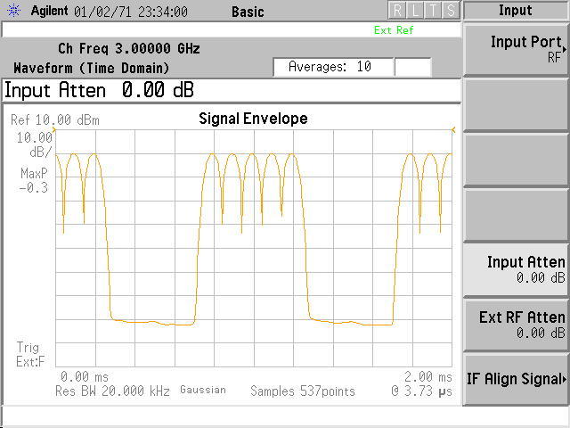

The external I/Q modulation circuits are the same in both the SG380 series and SG390 series RF signal generators, and so these results are expected to hold for all of these instruments. External I/Q modulation is an option in the SG380 series instruments and a standard feature in the SG390 series instruments.

