TDS3UAM and TDS3ENG module creation instructions
TDS3UAM

Universal Application Module for Tektronix TDS3000 Series Oscilloscopes

Newer versions of the Tektronix firmware for TDS3000 oscilloscopes provide the TDS3FFT and TDS3TRG functionality by default. There are other features available which are enabled by plug-in modules;

TDS3AAM Provides useful waveform math functions. TDS3VID Video line triggering.
TDS3LIM Limit test waveforms with user created masks. TDS3TMT Mask testing for some standard telecoms signals.
TDS3SDI Serial Digital

Each of these modules contains one 256 byte I2C EEPROM with a null terminated string “TDS3xxx” starting at address 0x04 to enable the corresponding features. By using a 1Kbyte or larger EEPROM all features can be enabled using just one physical module. EEPROMs larger than 2Kbytes have an additional address byte and are not compatible.
:10000000FFFFFFFF5444533341414D00FFFFFFFF0B
:10005000FFFFFFFF76312E303000FFFFFFFFFFFF75
:10010000FFFFFFFF544453334C494D00FFFFFFFFF7
:10015000FFFFFFFF76312E303000FFFFFFFFFFFF74
:10020000FFFFFFFF54445333544D5400FFFFFFFFE3
:10025000FFFFFFFF76312E303000FFFFFFFFFFFF73
:10030000FFFFFFFF5444533356494400FFFFFFFFF4
:10035000FFFFFFFF76312E303000FFFFFFFFFFFF72
:00000001FF

Intel Hex File “TDS3UAM.hex” The suggested parts to make a TDS3UAM are;
Tektronix TDS3000 Dummy/Empty Module Sim-Card Connector (e.g. Nokia 1110 type) 24C16 EEPROM SOIC8 5V
Blob of Blu-Tack

The 24C16 EEPROM has more memory than is actually required but has a useful feature – pins 1, 2 & 3 are not connected which makes soldering it to the SIM connector a little easier.

Procedure

- Erase the EEPROM then program it with the Intel Hex file given above. To create the hex file, simply copy and paste everything inside the box above to a new text file named “TDS3UAM.hex”.

- Lay the EEPROM upside down on the solder side of the SIM connector

- Make the connections shown in the following pictures. Only one jumper wire is needed, all other connections can be done with solder bridges. It seems to work fine without a supply de-coupling capacitor fitted.

- Assemble the EEPROM and SIM connector into the empty module at the position shown.

- Plug it in to the scope and check the features are enabled.

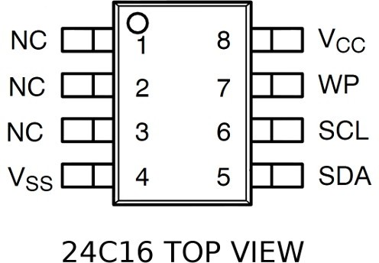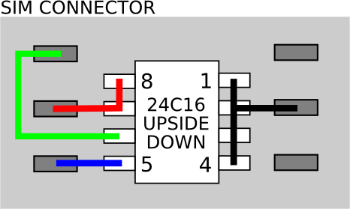

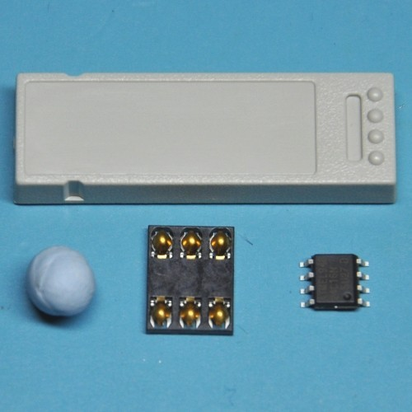
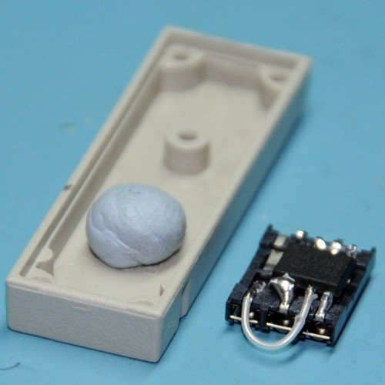

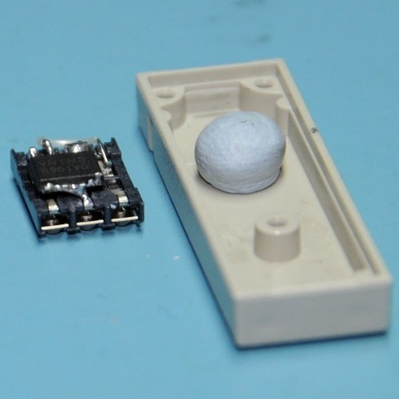
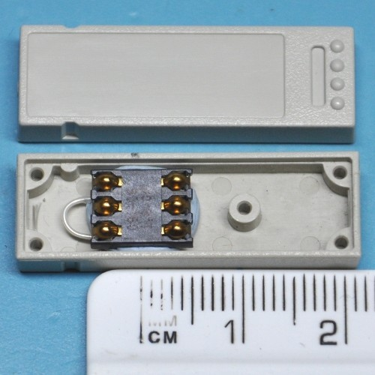

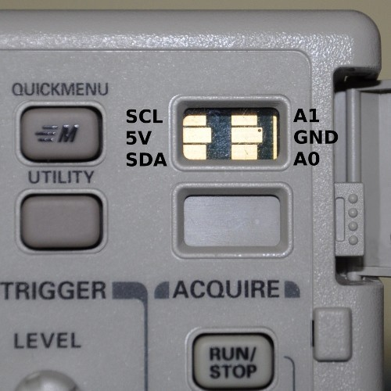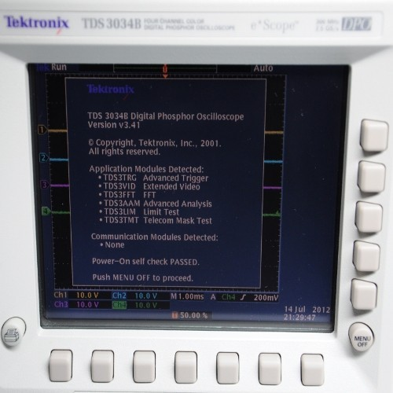

TDS3ENG

Engineering All Application Module for Tektronix TDS3000 Series Oscilloscopes

Newer versions of the Tektronix firmware for TDS3000 oscilloscopes already provide the TDS3FFT and TDS3TRG functionality by default. The features available which are enabled by the TDS3ENG plug-in module;

TDS3AAM Provides useful waveform math functions. TDS3VID Video line triggering.
TDS3LIM Limit test waveforms with user created masks. TDS3TMT Mask testing for some standard telecoms signals.
TDS3SDI Serial Digital functions.
TDS3TRG Video line triggering.
TDS3FFT FFT
TDS3BTA BETA functions.

Same as the TDS3UAM instructions copy and paste the data in the blocks into a Notepad file and save it as TDS3ENG.HEX. I have two blocks here, the first one is the original as above but with only the TDS3ENG code. The second block is the one I used which is from the file TDS3ENG.HEX file found in this thread.

Only difference is that the first block relies on you having erased the EEPROM, the second writes the entire 256 byte filling in FF in all unused locations, just in case you made an Oops and forgot the erase.

I have reprogrammed existing TDS3TRG and TDS3FFT modules. The programmer did not detect every module EEPROM (a 24C02). It is my untested theory that they be slower 100 Khz ICs. In that case the module easily pries apart with a sharp EXACT knife, allowing you to replace the 24C02.

Here is a screen shot of the original module contents:

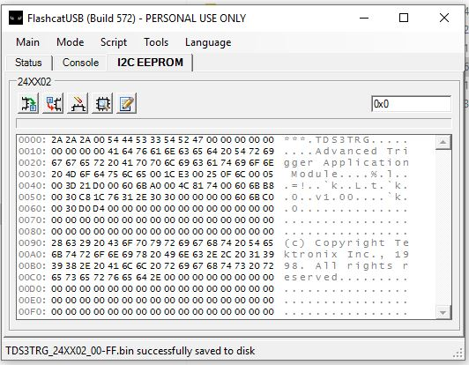

The critical part of the contents are the TDS3TRG entry and the v1.00 entry. I noticed that the TDS3TRG and v1.00 start 4 bytes in so that is probably critical.

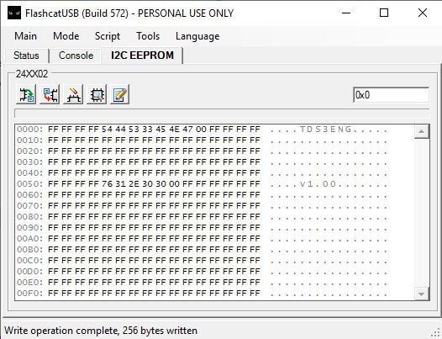
:10000000FFFFFFFF54445333454E4700FFFFFFFF00
:10001000FFFFFFFFFFFFFFFFFFFFFFFFFFFFFFFFF0
:10002000FFFFFFFFFFFFFFFFFFFFFFFFFFFFFFFFE0
:10003000FFFFFFFFFFFFFFFFFFFFFFFFFFFFFFFFD0
:10004000FFFFFFFFFFFFFFFFFFFFFFFFFFFFFFFFC0
:10005000FFFFFFFF76312E303000FFFFFFFFFFFF75
:10006000FFFFFFFFFFFFFFFFFFFFFFFFFFFFFFFFA0
:10007000FFFFFFFFFFFFFFFFFFFFFFFFFFFFFFFF90
:10008000FFFFFFFFFFFFFFFFFFFFFFFFFFFFFFFF80
:10009000FFFFFFFFFFFFFFFFFFFFFFFFFFFFFFFF70
:1000A000FFFFFFFFFFFFFFFFFFFFFFFFFFFFFFFF60
:1000B000FFFFFFFFFFFFFFFFFFFFFFFFFFFFFFFF50
:1000C000FFFFFFFFFFFFFFFFFFFFFFFFFFFFFFFF40
:1000D000FFFFFFFFFFFFFFFFFFFFFFFFFFFFFFFF30
:1000E000FFFFFFFFFFFFFFFFFFFFFFFFFFFFFFFF20
:1000F000FFFFFFFFFFFFFFFFFFFFFFFFFFFFFFFF10
:00000001FF

:10000000FFFFFFFF54445333454E4700FFFFFFFF0B
:10005000FFFFFFFF76312E303000FFFFFFFFFFFF75
:10010000FFFFFFFFFFFFFFFFFFFFFFFFFFFFFFFFFFF7
:10015000FFFFFFFFFFFFFFFFFFFFFFFFFFFFFFFFF74
:10020000FFFFFFFFFFFFFFFFFFFFFFFFFFFFFFFFFFE3
:10025000FFFFFFFFFFFFFFFFFFFFFFFFFFFFFFFFF73
:10030000FFFFFFFFFFFFFFFFFFFFFFFFFFFFFFFFFFF4
:10035000FFFFFFFFFFFFFFFFFFFFFFFFFFFFFFFFF72
:00000001FF

The next two photos show the connections to the module. Note that it was not required to ground A0 and A1. As a side note, the WP line is tied to GND enabling READ/WRITE operation.

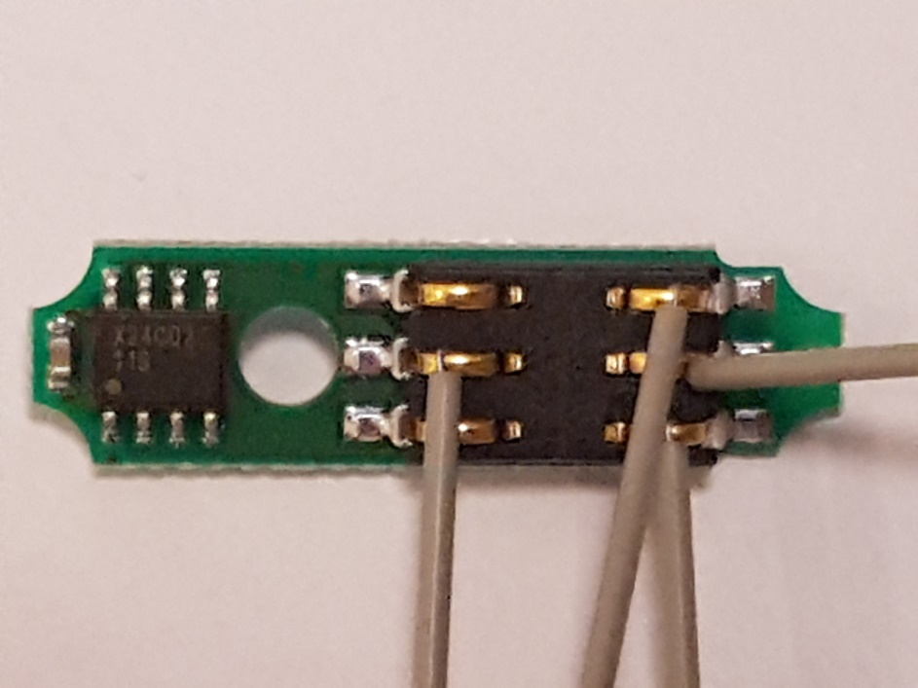

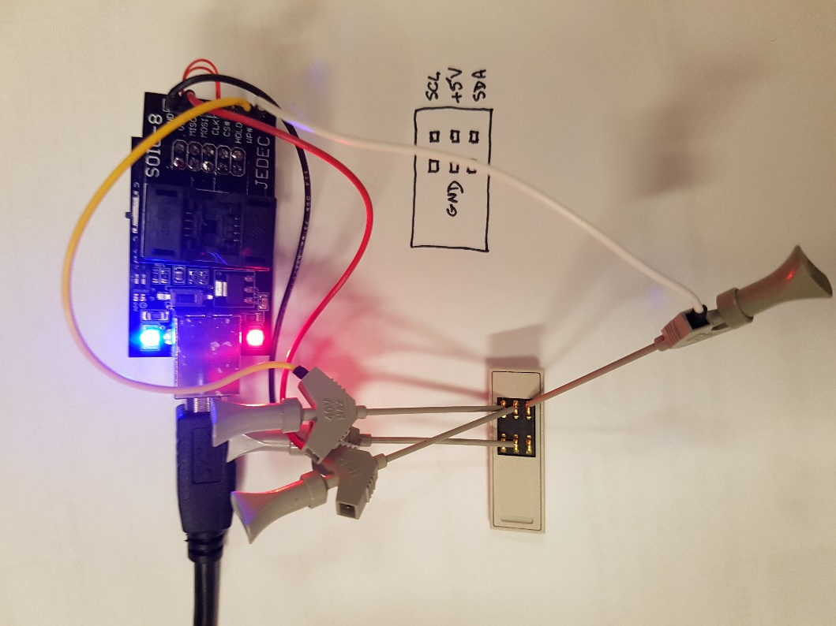

This shows the back cover pried off. The pins on the cover are a friction fit to hold it in place, I started removal on the short side by the EEPROM.

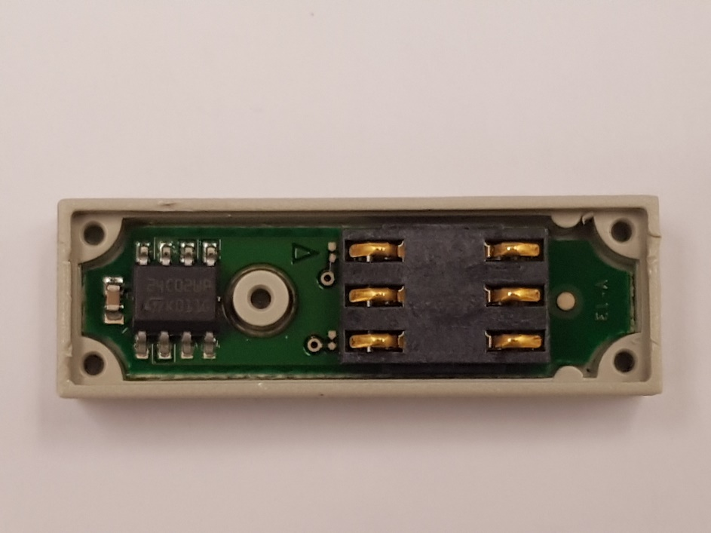

After programming insert the module and test. I have tested it in a altered TDS3012 (TDS3052) and a TDS3014B (TDS3064B)

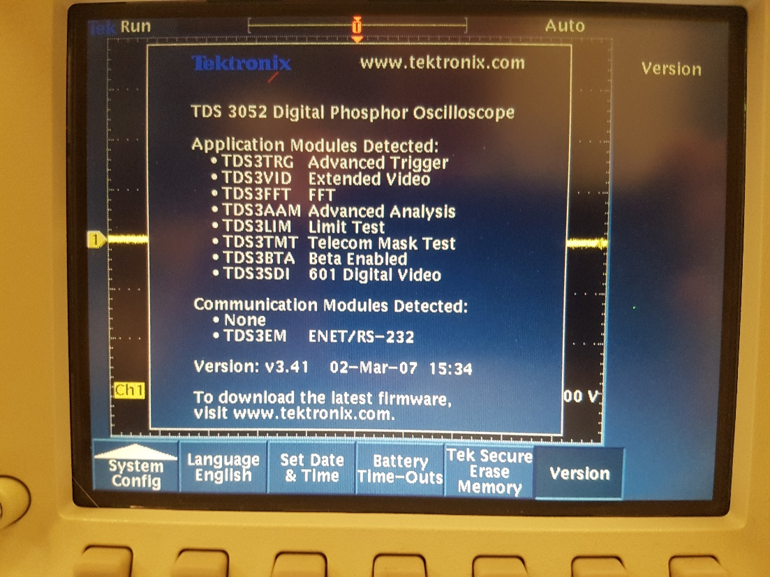

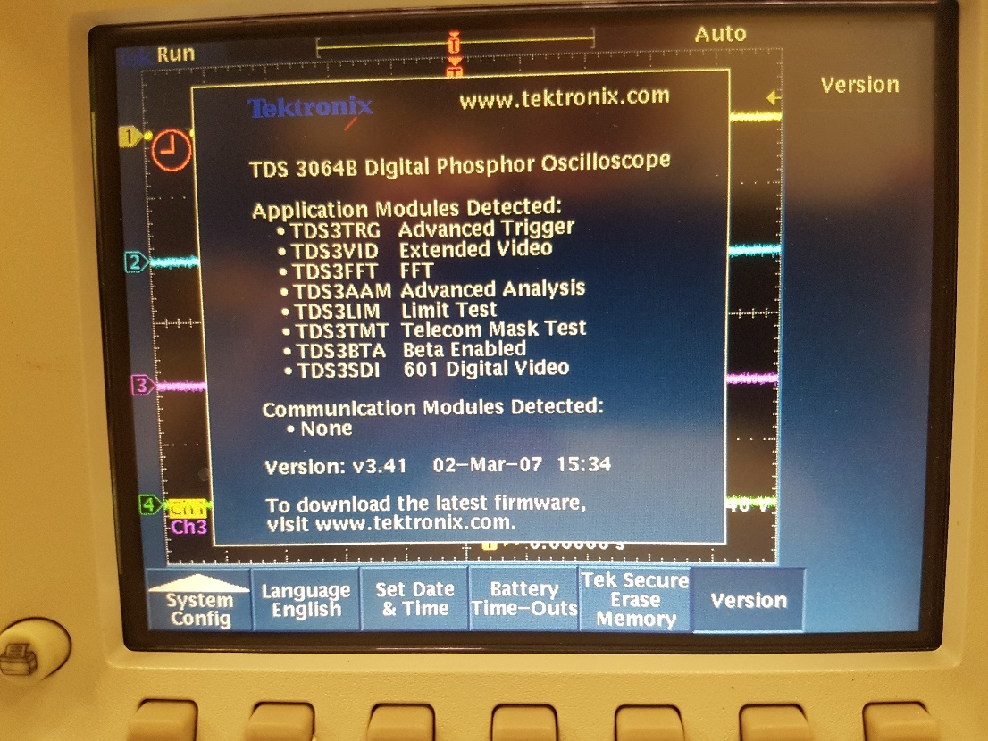

Many, many thanks to EEVBlog member haertig for his kind assistance. A plug for the Flashcat, it was very easy to use, intuitive software. I ordered the FlashcatUSB Classic FCUSB2X SOIC-8 Narrow. I soldered a single row header in the space provided on the SOIC-8 board to break out the signals. When you unzip the software download the manual is inside, it details the I2C pinouts. WP is SDA, HOLD is SCL. +5V and GND are as per the silk screen. For connections I used some nifty Tek micro clips from a scrapped Logic Analyzer. Note that the header and clips are 2 mm not 0.100.

