TDS3000 v2.1.2 New Sep 10, 2017

Changes from 2.1.1 to 2.1.2

Bugfixes:
Selecting Full Sequence didn't clear Test Status display.
Create New Log File didn't clear Test Status display.
AppTitle missing last letter.
Import/Append Log File didn't work properly and didn't provide relevant Error message in case of missing or corrupt file or folder.

Changes:
New version of embedded GPIB Communicator.
New version of embedded Error Log Viewer.
Main, GPIB Com and Error Log Viewer added to View Modules.
Remove Signals message in Offset Zero test skipped if Full Sequence and SPC was done.
Menu Utilities/GPIB Communication renamed to GPIB Communicator.

Known Issues:
Change Type does not support TDS 3064B and none of the C-models.
Reading the Error Log or Change Type does not work on scopes with F/W 3.41. That Error Log doesn't work has been confirmed by Tek in a slightly cryptic reply.
A work around if you want to change type and already have 3.41 is to temporarily load v3.39 which works. Download 3.39 here. Latest version could be found on Tek's website.

Changes from 2.1.0 to 2.1.1

Bugfix:
All 300 MHz scopes failed BW test. Thanks Bob H for letting me know.

Changes from 2.0.0 to 2.1.0

Bugfixes:
Incorrect GPIB command in Adjustment procedure (Auto mode only).
Incorrect amplitude settings for Trigger test on B and C models.
Incorrect Limit for Sample Rate check on C models.
Test Aborted message was not shown in Trig Test when Exit Test was selected.

Changes:
Adjustment procedure changed to work with and verified for 4 ch B-models.
Change Type procedure and messages slightly changed.
Support for TDS 3064B added on PV and adjust but not Change Type.
Ext Trig Connection message at start of Auto mode deleted.
50 ohm terminators reminder message when starting Gain test in Auto mode deleted.
Handling of various SG/TDS combinations changed so two generators could be used for BW and Trig tests on some TDS's.

2.0.0
This is the first published version.
Please, note that this could be considered a beta version since I have only been able to test it fully on a TDS 3014 changed to TDS 3054.
So there may still be some bugs or issues I haven't detected yet. Use the email link at the bottom of this page to report whatever you find.
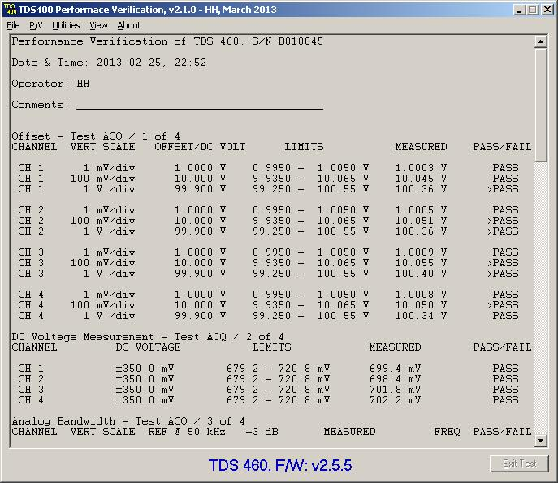
Gents -
I've seen this come up a number of times as to how to extend the BW of these scopes. Here is some information that I will share, although I have only tested several models and it did work on the two non lettered versions that I have.
I particular, I was able to update a TDS3034 to TDS3054 (non-lettered) and a TDS1001 to TDS1012
I will leave it up to the group to try this out on the 'B' and 'C' models to see if it works.
In regards to the TDS3000 models, the non-lettered and B models only will accommodate fw ver 3.41. V3.41 does not work. I had to downgrade to 3.39, perform the change and upgrade back to 3.41. This worked. The TDS3000 C models have not be tried.
If any of this information has already been posted, I am unaware. Please use at your own risk.
You will need to setup your TekVisa OpenChoice tools and run the Talk/Listener tool in order to force
SCPI commands to your unit, either through USB or GPIB.
Use *IDN? to check communications
For the TDS3000 series (downgraded to 3.39, then re-updated to 3.41)
Send the following:
PASSWORD PITBULL
MCONFIG TDS3054
You will not get any feedback from the unit. Reboot the unit and check to see if it worked. Again, with V3.39 it worked great.
For the TDS1000/2000
PASSWORD PITBULL
MODEL TDS20xx (with xx = model #)
I have not tested with 'B' and 'C' models so report back what you find out.
Good luck.

I can confirm that this hack works on TDS3034B and TDS3032.
"B" series has the same firmware as non lettered series. I've downgraded the firmware to 3.39, did the hack via RS232 and upgraded back to 3.41 (it's so hard to find 3.5" floppy disks and working FDD these days). Don't forget to do calibration after the whole procedure!
For TDS3032 I used "MCONFIG TDS3052" and for TDS3034B "MCONFIG TDS3054B". Upgrading the bandwidth to 500 MHz also upgrades sampling rate to 5 GSPS. This is really impressive and gives those old dogs new life.
This hack creates nice combo with application dongles hack (https://www.eevblog.com/forum/projects/tektronix-tds3000-oscilloscope-modules-tds3uam/).

Thanks for the great tips about upgrading the TDS3000B series!
I just tried it on a fw 3.27 TDS3014B and it now happily runs up to 500MHz. Didn't even need to use TekVISA, you can enter the commands via ethernet using the scope's own webpage (B series have built in ethernet).
I have just realised that there was a 600MHz version too - does anyone know if TDS3064B is an option as well? I can't try it myself until monday.

I have tried to upgrade a Tek TDS2014 to a TDS 2024 and used this commands, posted by rfdes
For the TDS1000/2000
PASSWORD PITBULL
MODEL TDS20xx (with xx = model #)
But I had no luck, scope is still TDS 2014.
Connection via GPIB was established and I have tried different software to send the commands.
It seems that the scope could read it, but it does nothing. But when I made an intentional error like PetBULL instead of PITBULL it gaves back an error.
Firmware is 4.12.
Is it not working with this firmware or did I overlooked something?
Any hints?

I forgot to mention that for the TDS1000/2000 and TDS200 instruments, the BW update will not be saved unless a full calibration adjustment is performed before the unit is shutdown.

just pimped-up a TDS3014B, no issue.
Btw, no need for GPIB, the web-interface perfectly does the job for the B-series (or a TDS3EM equipped non-B)

FYI, I've verified that the procedure detailed at the beginning of this thread works on a TDS3012 (no letter suffix) with no issues. I downgraded from v3.41 to v3.39, applied, the hack, and reinstalled v3.41. I set the model to TDS3052. I used the command functionality in the web interface from a browser while the oscilloscope was connected to my network.
Quick and dirty measurement with a Bodnar pulser (38ps rise time measured on an 11801A+SD26) showed a rise time of 2.3ns before the hack, and 1.0ns after. No other measurements performed as of yet.
I did notice that there was a significant DC offset after the hack. I'm pretty sure that wasn't there beforehand. Running signal path compensation took care of it, now it's perfect.

I am reporting success too, with my TDS 3014B converted to a TDS 3064B
I got this scope in an auction sale, and now I have a really fast sampling rate, thanks for the hack!
The upgrade process is not difficult, but I got some troubles with upgrading the firmware, so I am posting some infos for helping others:
You will need:
- a network connection between the TDS 30xxB and a computer with a web browser.
- 4 floppy disks 3"1/2 1.44MB (at least one).
- the firmware v3.39 (see above posts).
  - Configure network
Plug the ethernet cable
On the scope: go to Utility -> I/O -> Ethernet Network Settings and enable DHCP/BOOTP
After a few seconds, the oscilloscope will display its IP address, just enter it in your web browser.
(Your network must run a DHCP server, otherwise you have to configure a static IP address)
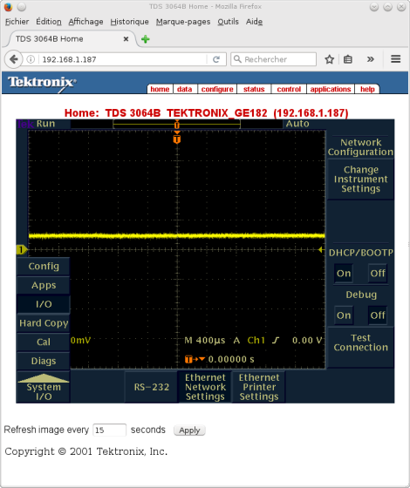
- Check firmware version
One way to check the firmware is to send the command "*IDN?" from the "data" tab of the TDS's web page:
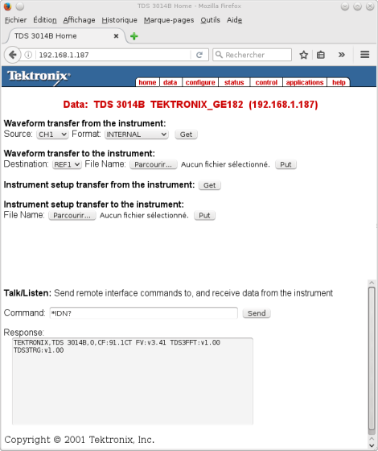
- Downgrade to v3.39
If your TDS is running version 3.41, the hack won't work, you have to downgrade to an older version. If your current firmware version is older than 3.41, it should work directly (see other posts), so you can jump to next step.
Be careful with the updates, some versions has some quirks, read Tektronix recommendations! (for example, version 1.0 must be upgraded really carefully because of a bug in this version. Switching from version prior to 2.20 to version above 2.21 will need a recalibration, ...)
So let's upgrade / downgrade the firmware using floppy disks. I don't know if there are other means to change the firmware? I didn't find any...
I had formatted and prepared some floppy disks on an old computer, but the TDS refused to boot on it, so I strongly advice to format the floppy directly on the TDS: use save/recall menu:
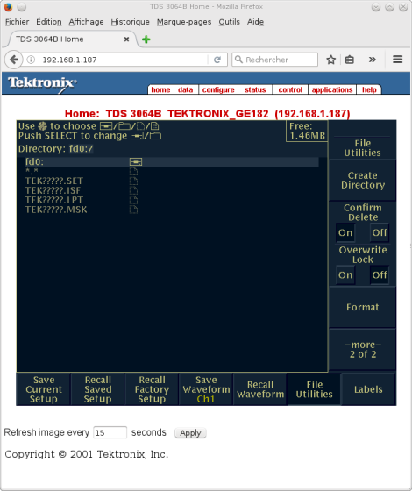
If something is wrong with the floppy, the TDS scope will display "Mass storage error":
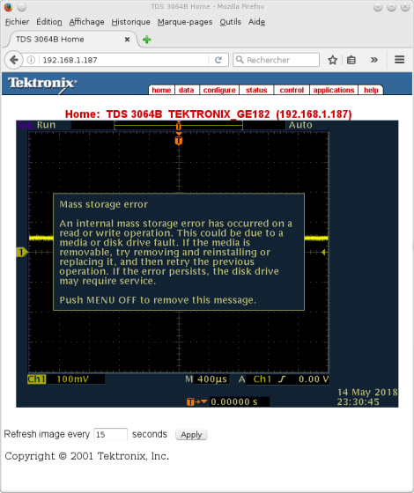
So try another floppy! Many of my old floppies were bad (particularly the Sony ones) ; back in time of 5"1/4 floppy, I had noticed that BASF one were more reliable than others ; so I searched for some old 3"1/2 BASF floppy disks and, guess what, they all worked in the TDS
Once formatted in the scope, you have to unzip and copy the firmware v3.39 to the floppy disks. The content of each directory (disk1 to disk4) must be copied on four separate floppy disks, without creating any directory.
Take care to label each floppy disk with the name "disk1" to "disk4", this is needed by the TDS.
Once formatted by the oscilloscope, I run these commands on my Linux server (the only one that stills has a floppy disk drive):
[/list]
Code: [Select]
mlabel a:disk1 && mount /media/floppy/ && cp -av /home/share/temp/firmware_v3.39/disk1/* /media/floppy/ && umount /media/floppy(don't forget to change all the "disk1" to "disk2" for the next floppy, etc...)
Last step is to stop the scope, insert the first floppy into the TDS and power it on. If you followed the above instructions, the scope will ask if you want to downgrade / upgrade the firmware: just follow the instructions
- Bandwith hack
Connect again to the web interface and check that firmware version is lower than v3.41, using "*IDN?" command for example.
Now send the correct commands for hacking the bandwith: for my TDS 3014B it is:
PASSWORD PITBULL
MCONFIG TDS3064B
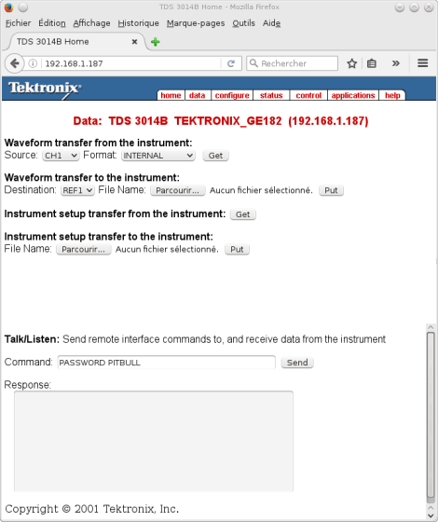 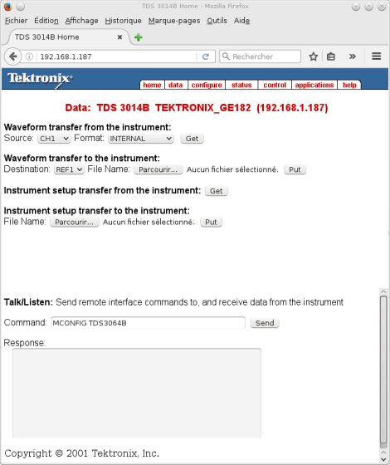
Power OFF then ON the TDS, and enjoy!
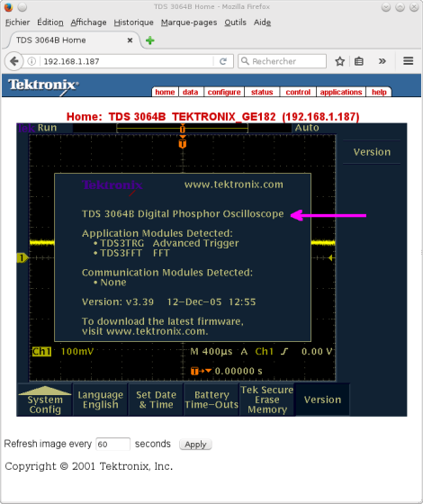
(you can now upgrade again to v3.41, the scope won't loose it's model number)

I had no problem reprogramming the stock FFT application module with the TDS3ENG firmware - it took the first time and opened up everything as touted.
I used a Flashcat programmer from embeddedcomputers.com. Note that whatever programmer you use, it must provide pull ups on the SDA & SCL lines to program an I2C module. I bought one of their standard narrow SOIC8 I2C adapters which has the pull ups installed, then installed a 4 pin header in the holes conveniently provided which parallel the socket connections. I connected to the chip in the FFT application module using a nice Pomona test clip that I bought on e-bay and connected it back to the programmer with some standard FxF header jumpers, arranging them appropriately so things were connected to the right places.
Total cost about $50. You could do cheaper by buying the bare programmer and using a chinesium test clip and making the appropriate jumper including pull ups.

