TDS3000 v2.1.2 New Sep 10, 2017

Changes from 2.1.1 to 2.1.2

Bugfixes:
Selecting Full Sequence didn't clear Test Status display.
Create New Log File didn't clear Test Status display.
AppTitle missing last letter.
Import/Append Log File didn't work properly and didn't provide relevant Error message in case of missing or corrupt file or folder.

Changes:
New version of embedded GPIB Communicator.
New version of embedded Error Log Viewer.
Main, GPIB Com and Error Log Viewer added to View Modules.
Remove Signals message in Offset Zero test skipped if Full Sequence and SPC was done.
Menu Utilities/GPIB Communication renamed to GPIB Communicator.

Known Issues:
Change Type does not support TDS 3064B and none of the C-models.
Reading the Error Log or Change Type does not work on scopes with F/W 3.41. That Error Log doesn't work has been confirmed by Tek in a slightly cryptic reply.
A work around if you want to change type and already have 3.41 is to temporarily load v3.39 which works. Download 3.39 here. Latest version could be found on Tek's website.

Changes from 2.1.0 to 2.1.1

Bugfix:
All 300 MHz scopes failed BW test. Thanks Bob H for letting me know.

Changes from 2.0.0 to 2.1.0

Bugfixes:
Incorrect GPIB command in Adjustment procedure (Auto mode only).
Incorrect amplitude settings for Trigger test on B and C models.
Incorrect Limit for Sample Rate check on C models.
Test Aborted message was not shown in Trig Test when Exit Test was selected.

Changes:
Adjustment procedure changed to work with and verified for 4 ch B-models.
Change Type procedure and messages slightly changed.
Support for TDS 3064B added on PV and adjust but not Change Type.
Ext Trig Connection message at start of Auto mode deleted.
50 ohm terminators reminder message when starting Gain test in Auto mode deleted.
Handling of various SG/TDS combinations changed so two generators could be used for BW and Trig tests on some TDS's.

2.0.0
This is the first published version.
Please, note that this could be considered a beta version since I have only been able to test it fully on a TDS 3014 changed to TDS 3054.
So there may still be some bugs or issues I haven't detected yet. Use the email link at the bottom of this page to report whatever you find.
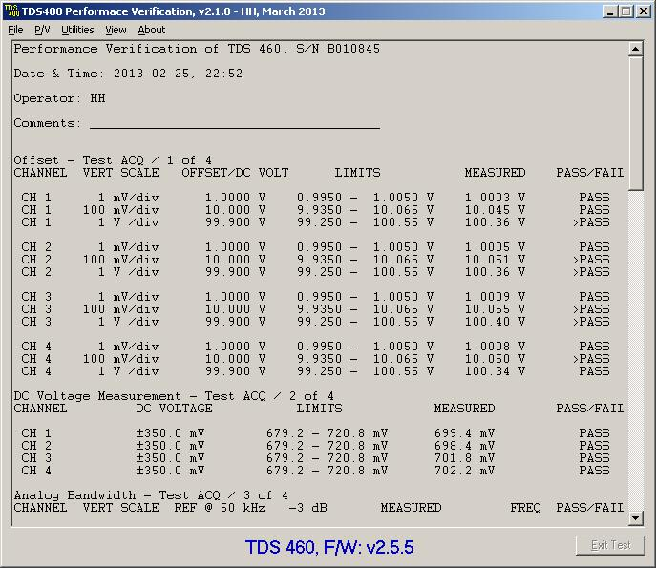
Gents -
I've seen this come up a number of times as to how to extend the BW of these scopes. Here is some information that I will share, although I have only tested several models and it did work on the two non lettered versions that I have.
I particular, I was able to update a TDS3034 to TDS3054 (non-lettered) and a TDS1001 to TDS1012
I will leave it up to the group to try this out on the 'B' and 'C' models to see if it works.
In regards to the TDS3000 models, the non-lettered and B models only will accommodate fw ver 3.41. V3.41 does not work. I had to downgrade to 3.39, perform the change and upgrade back to 3.41. This worked. The TDS3000 C models have not be tried.
If any of this information has already been posted, I am unaware. Please use at your own risk.
You will need to setup your TekVisa OpenChoice tools and run the Talk/Listener tool in order to force
SCPI commands to your unit, either through USB or GPIB.
Use *IDN? to check communications
For the TDS3000 series (downgraded to 3.39, then re-updated to 3.41)
Send the following:
PASSWORD PITBULL
MCONFIG TDS3054
You will not get any feedback from the unit. Reboot the unit and check to see if it worked. Again, with V3.39 it worked great.
For the TDS1000/2000
PASSWORD PITBULL
MODEL TDS20xx (with xx = model #)
I have not tested with 'B' and 'C' models so report back what you find out.
Good luck.

I can confirm that this hack works on TDS3034B and TDS3032.
"B" series has the same firmware as non lettered series. I've downgraded the firmware to 3.39, did the hack via RS232 and upgraded back to 3.41 (it's so hard to find 3.5" floppy disks and working FDD these days). Don't forget to do calibration after the whole procedure!
For TDS3032 I used "MCONFIG TDS3052" and for TDS3034B "MCONFIG TDS3054B". Upgrading the bandwidth to 500 MHz also upgrades sampling rate to 5 GSPS. This is really impressive and gives those old dogs new life.
This hack creates nice combo with application dongles hack (https://www.eevblog.com/forum/projects/tektronix-tds3000-oscilloscope-modules-tds3uam/).

Thanks for the great tips about upgrading the TDS3000B series!
I just tried it on a fw 3.27 TDS3014B and it now happily runs up to 500MHz. Didn't even need to use TekVISA, you can enter the commands via ethernet using the scope's own webpage (B series have built in ethernet).
I have just realised that there was a 600MHz version too - does anyone know if TDS3064B is an option as well? I can't try it myself until monday.

I have tried to upgrade a Tek TDS2014 to a TDS 2024 and used this commands, posted by rfdes
For the TDS1000/2000
PASSWORD PITBULL
MODEL TDS20xx (with xx = model #)
But I had no luck, scope is still TDS 2014.
Connection via GPIB was established and I have tried different software to send the commands.
It seems that the scope could read it, but it does nothing. But when I made an intentional error like PetBULL instead of PITBULL it gaves back an error.
Firmware is 4.12.
Is it not working with this firmware or did I overlooked something?
Any hints?

I forgot to mention that for the TDS1000/2000 and TDS200 instruments, the BW update will not be saved unless a full calibration adjustment is performed before the unit is shutdown.

just pimped-up a TDS3014B, no issue.
Btw, no need for GPIB, the web-interface perfectly does the job for the B-series (or a TDS3EM equipped non-B)

