Instructions for using I2CSerial.exe

- Copy the executable file to your hard-drive.
- Connect your PC to the Master board via a RS-232 cable.
- Connect your Master device to your slave. Pull-up resistors are required for both SDA and SCL lines and a ground link should be present between both targets.
- Ensure that the ADuC7060 Master is programmed with the Master application contained in this .zip file.
- Similarly, the slave device should be programmed with the correct slave application.
- Open a Windows command window by typing “cmd” in the “Run” window. See Figure 1 for further details:

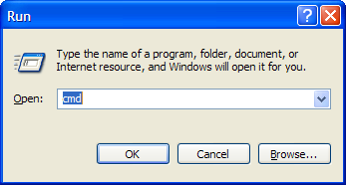
Figure 1.
- In the command window, type “I2CSerial.exe 1” to run the test application. The number “1” refers to the communications port on your P.C. that you wish to use. This number should change if you are not using communications channel 1. See Figure 2 for more details.

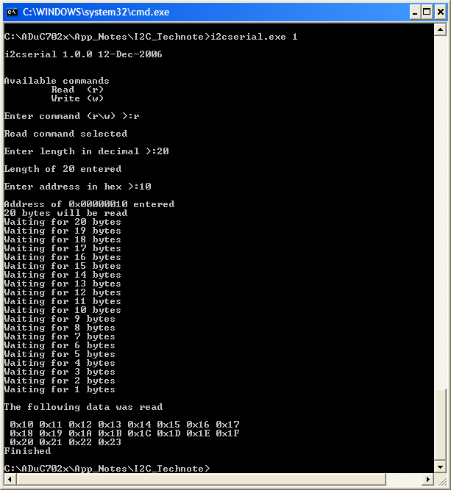

Figure 2.

- As shown in figure 2, when you run the I2CSerial.exe application, you will be prompted for the I2C command type – you must enter either “r” for a read cycle or “w” for a write cycle.

- Then you will be prompted for the length of data that you wish to read or write. Note the length must be less than 80 bytes. (See figure 2).

- Then you will be prompted for the start address that you wish access on the Slave part. You can only enter a value between 0x00 – 0xFF. (See figure 2).

