To run the Protocol 6 FlashEE Programmer CANoe.LIN configuration

Open Vector CANoe.LIN (version 7.0 or above is required).

Viewing the Panel

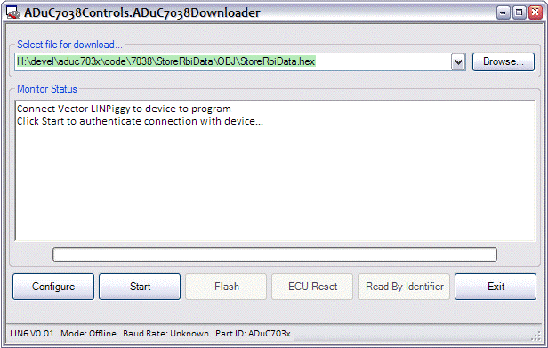

If you can not see the above panel, go to View -> ADuC7038Controls.ADuC7038Downloader

Using the Downloader

Use the ‘Browse…’ button to locate the Intel HEX file to programme to the ADuC7038.

Click ‘Configure’ to:
- General configuration options
- Specify the CRC type
- Assign a new NAD for the current Flash Programming sequence

Click ‘Start’ to:
Verify connection with the ADuC703x part and retrieve the part id

Click ‘Flash’ to begin FlashEE programming via LIN

Click ‘ECU Reset’ to reset the device after programming (if ‘Automatic Reset’ option not selected in ‘Configure’).

Click ‘Read By Identifier’ to retrieve the user-storable 15 bytes at the top of FlashEE memory (starting 19 bytes before the start of Kernel space).

Clicking ‘Exit’ will save all user selections and will close Vector CANoe.LIN.

