DIY 10kΩ reference resistor
Dipl.-Ing. André Bülau

I always wanted to make a 10 kΩ reference resistor myself and thought the hermetically sealed, wirewound Ohmite HS520A would be a good start [1]. It features the following preferences:

Resistor value: 10 kΩ
Tolerance: 0.1 %
Power rating: 1.5 W
Temperature coefficient: 3 ppm/K
Voltage rating: 900 V
min. operational temperatur: -10 °C
max. operational temperature: +80 °C

The resistor case is made of a brass tube with glass sealed feedthroughs soldered to it at both ends.
When the resistor arrived a first temperature measurement disappointed (see Figure 1). The measurement was performed with a Prema 5017SC and an incubator with Arroyo 5305 TEC controller. The result shows a linear part of α = -1.97 ppm/°C and quadratic component of β = -0.065 ppm/°C², so the resistor got tossed for a while into the drawer, until I came across an article by lymex on bbs.38hot.net [2]. A translated version of this article can be found attached.

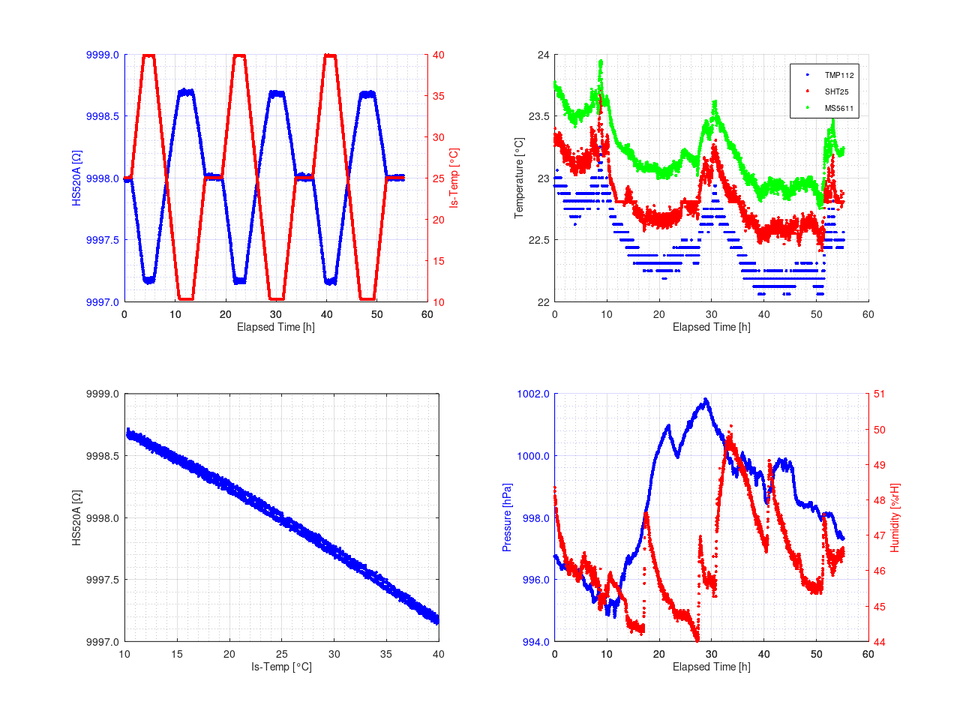Figure 1: Initial Temperature coefficient measurement

In his article, a resistor compensation scheme is describe using an NTC with series resistor Rp in parallel to Rm – this is our HS520A resistor – to compensate the quadratic component of the t.c., which adds an additional negative linear component to it. The overall negative linear component is then compensated with a copper wire resistor Rc and finally the arrangement is trimmed to its final value with Rs (see Figure 2).
The Excel spreadsheet to play with provided by lymex and translated to english can be downloaded in [3]

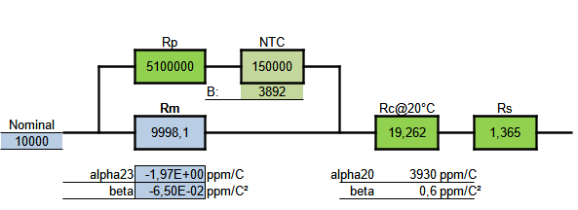Figure 2: Design stage to compensate for α and β

The 5.1 MΩ resistor together with a Littlefuse Inc. glass encapsulated thermistor type 154JG1K for compensating the β part was covered with a heat shrink tube and attached to the HS520A resistor. Another thermistor of type GA10kA3 with PTFE insulated leads was attached to the HS520A resistor acting as a temperature sensor. Everything was fixed with some Kapton tape around the HS520A (see Figure 3).

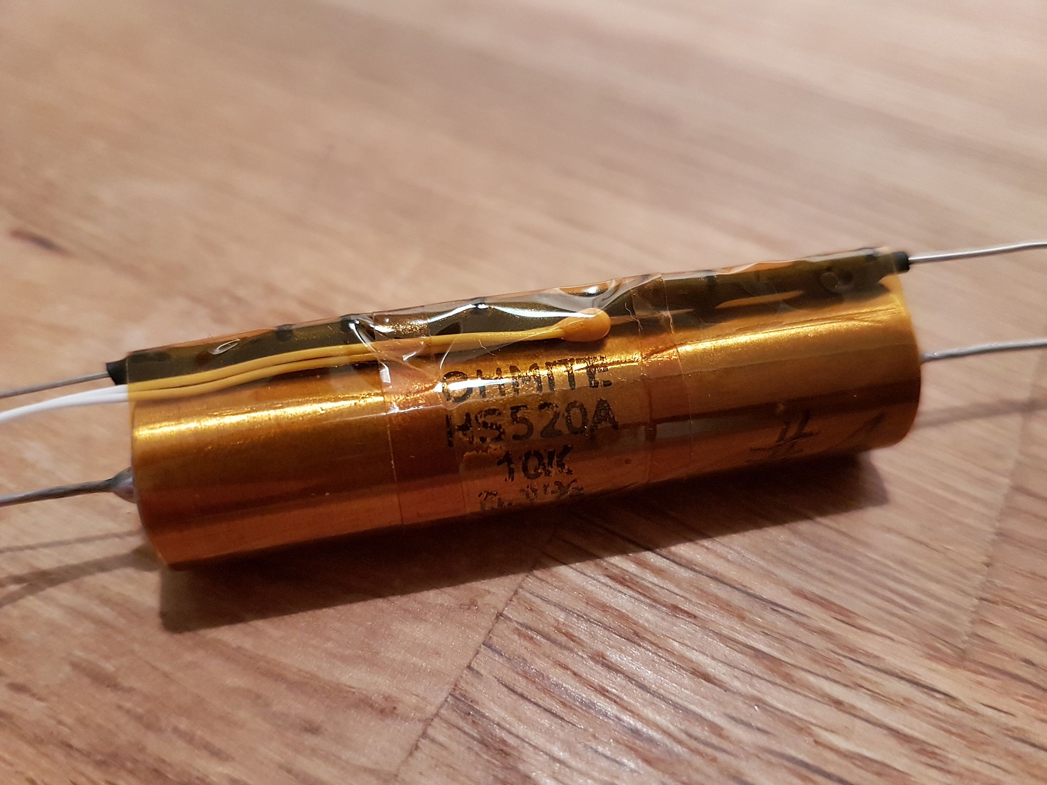Figure 3: HS520A with series resistor and NTC in a heat shrink tube parallel and a thermistor as temperature sensor attached to it

An enamealed copper wire of Ø0.16 mm was used for Rc and wound bifilar around the HS520A resistor case, again fixed with Kapton tape (see Figure 4). It compensates the negative linear component.

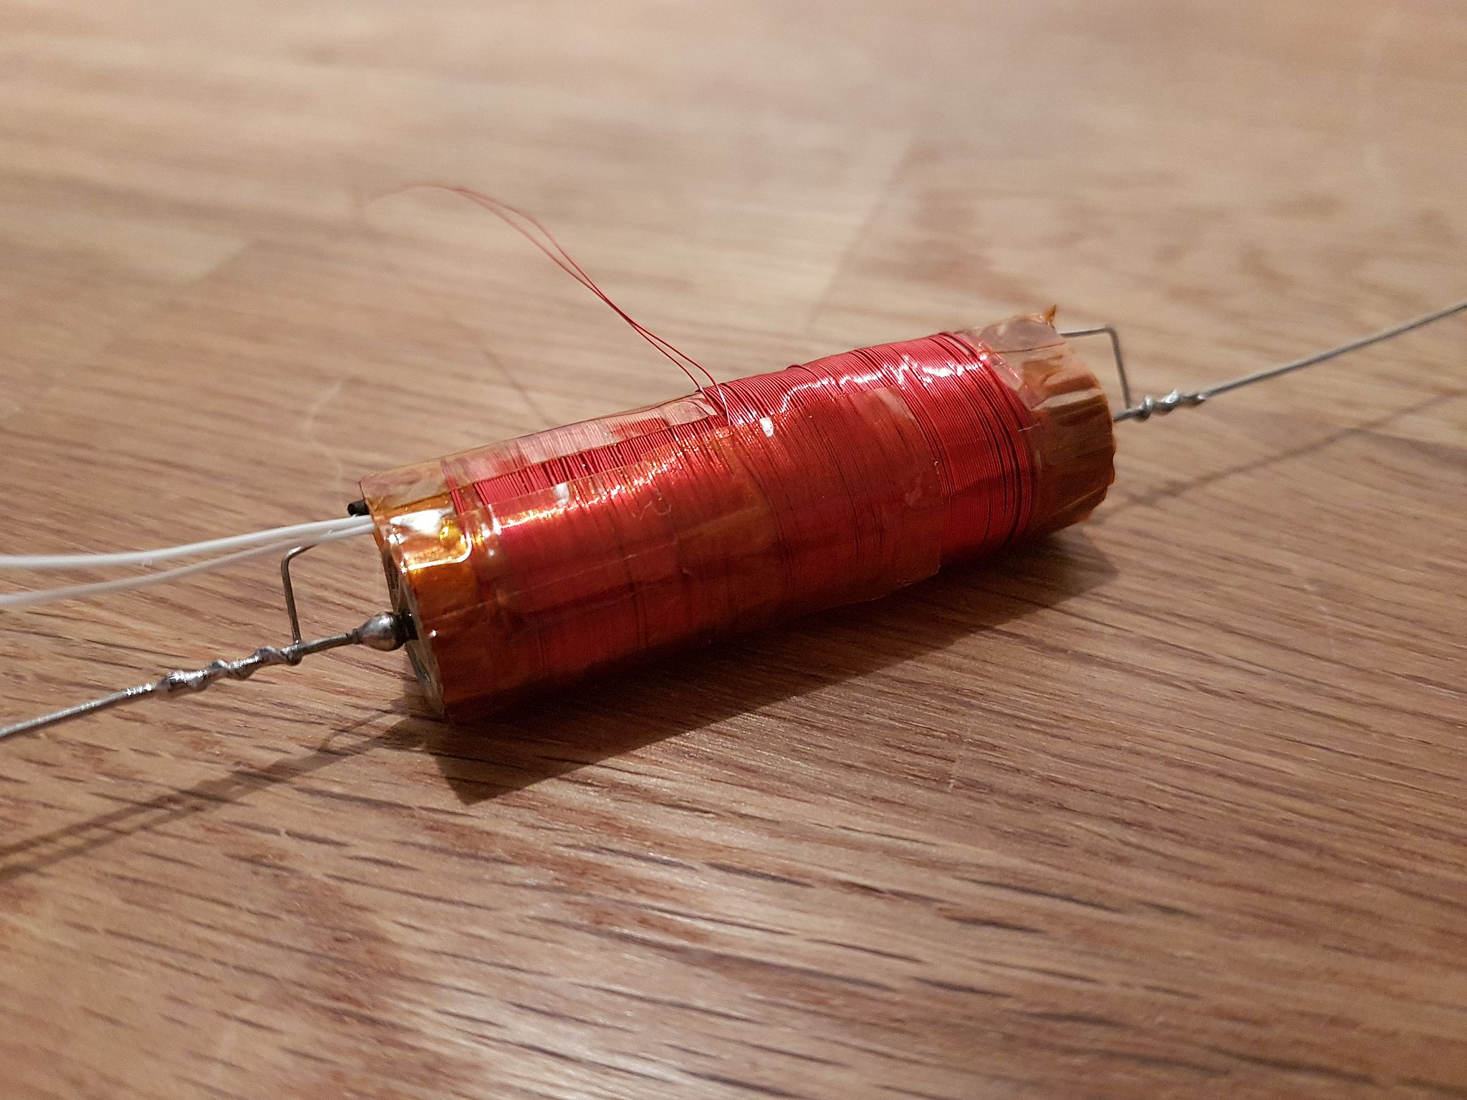Figure 4: Resistor with copper wire resistor wound to it

A Rose 04.08 12 08 pouder coated aluminum die cast case [4] was prepared with the holes for some POMONA 3770 binding posts. The resistor is attached by some Teflon standoffs to an aluminum mounting plate.
Rs was created by using 2x 2.7 Ω 1 % resistors with ±50 ppm/K (see Figure 5).

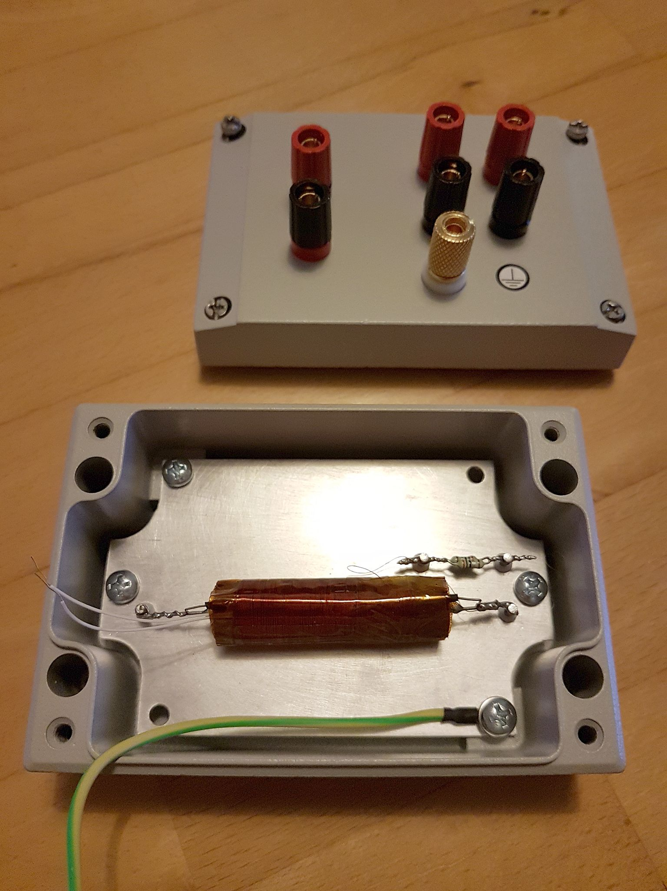Figure 5: Resistor in the Rose 04.08 12 08 pouder coated case with mounting plate and Teflon standoffs

After everything was set up a new temperature profile was performed, this time using a Solatron 7081 in 7x9 mode with the aformentioned thermal chamber. This resulted in the behavior presented in Figure 6. For the measurements the drift correction was turned off and manually initialized before every temperature run.

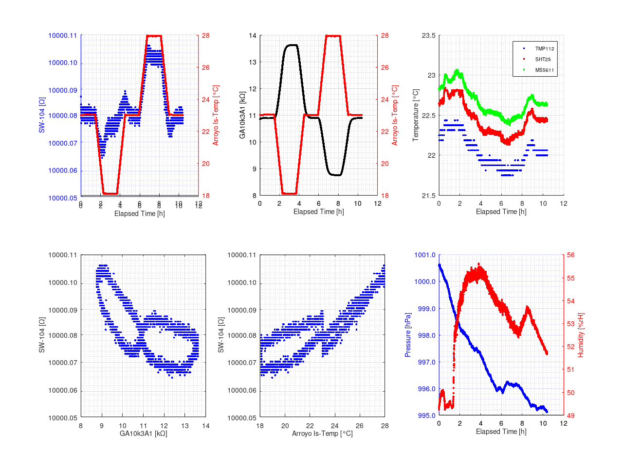Figure 6: Initial temperature measurement after setting everything up

From here the copper wire was then shortend by 10 cm and the temperature profile repeated (see Figure 7).

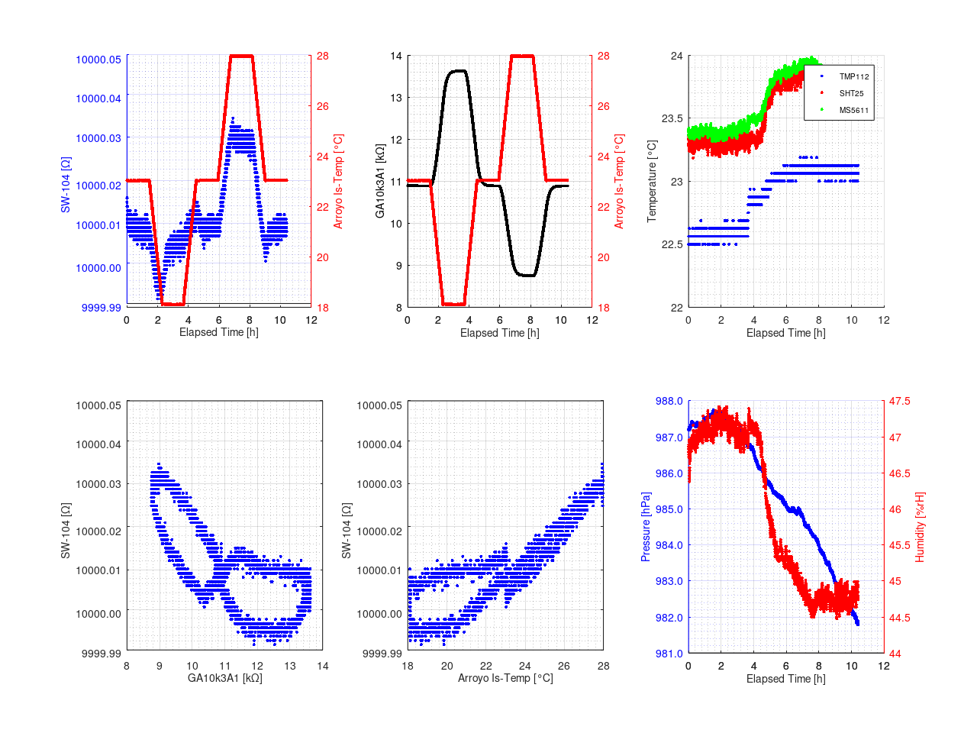Figure 7: Temperature measurement with 10 cm of copper wire removed.

The copper wire was shortened by another 20 cm and the temperature profile repeated (see Figure 8).

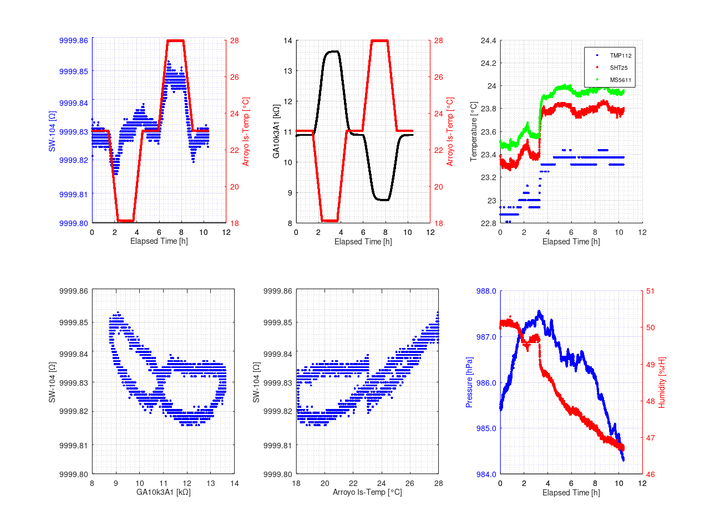Figure 8: Temperature measurement with 30 cm of copper wire removed.

Eventually, another 60 cm of copper wire were removed and the temperature profile repeated (see Figure 9).
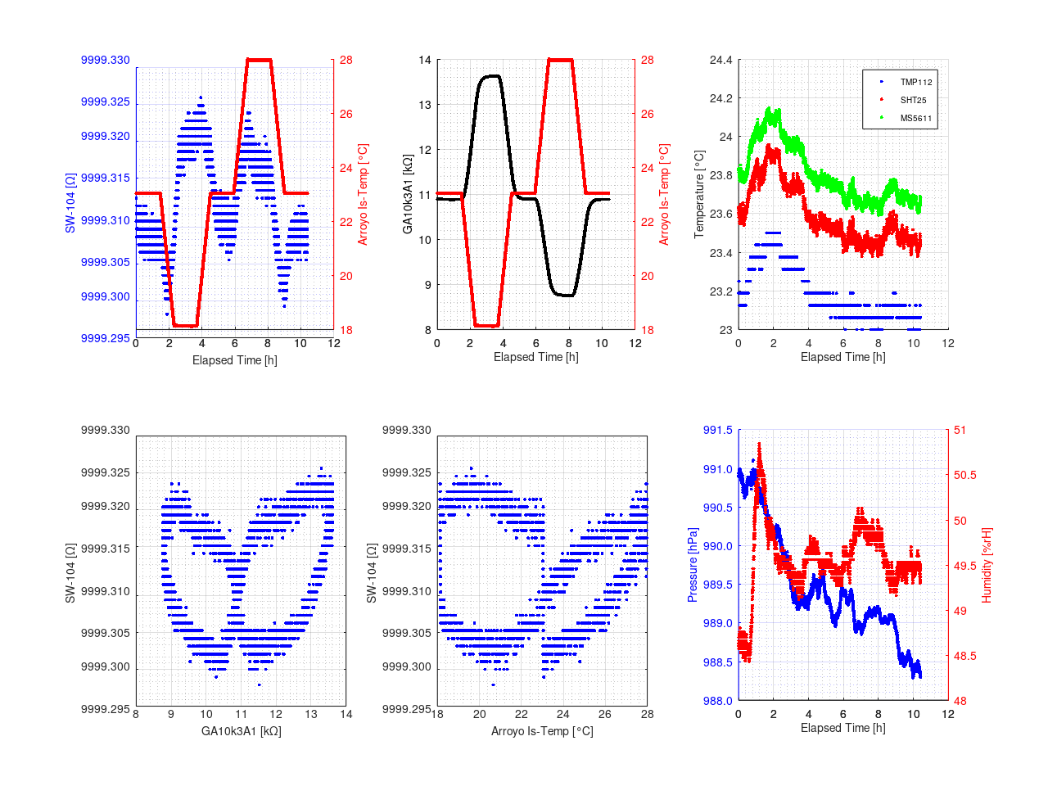Figure 9: Temperature measurement with 90 cm of copper wire removed.

The result shows an almost equally distributed temperature behavior. Finally, Rs was adjusted by replacing the 2x 2.7 Ω with 3.3 Ω || 5.6 Ω, as shown in the final trimming scheme in Figure 10.

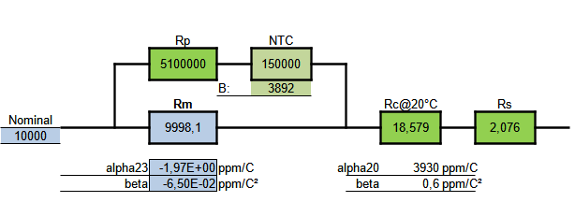Figure 10: Final trimming scheme

In this final arrangement the last temperature (see Figure 11) and an 8 h stability measurement at lab temperature right afterwards were performed (see Figure 12). For the stability measurement the drift correction of the Solatron 7081 was initialized every hour. It is visible, that it takes multiple hours, here about 5.5 … 6 h, for the resistor to fully stabilize after a temperature step.

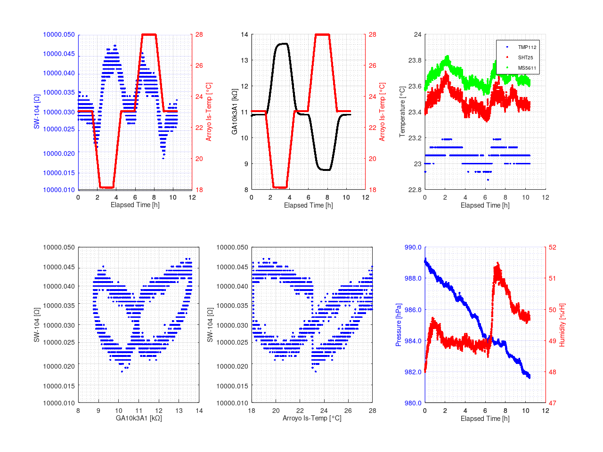Figure 11: Final temperature profile

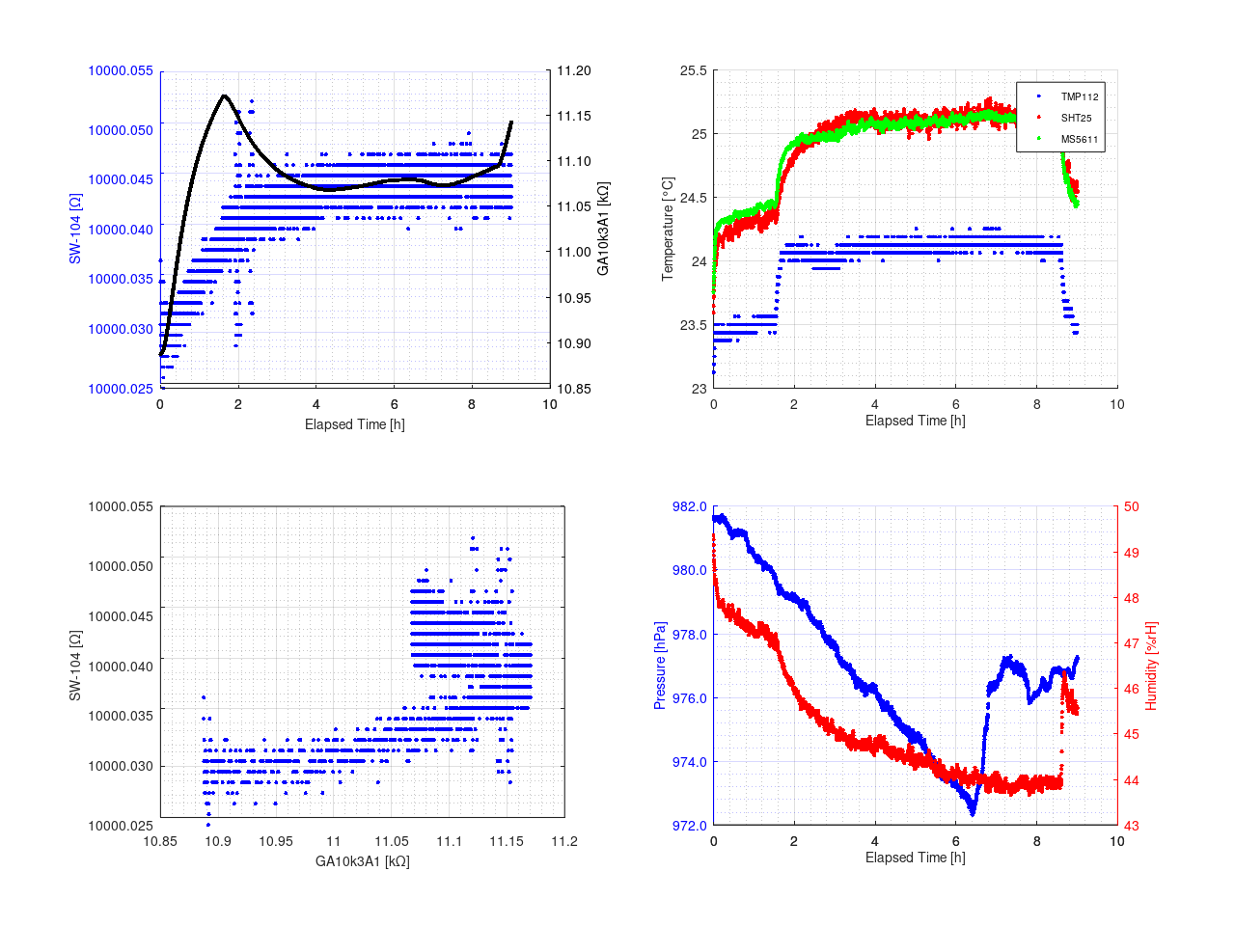Figure 12: 8 h stability test with drift compensation of Solatron 7081 turned off
Conclusion

A low t.c. resistor reference can be DIY (Figure 13). Allthough everything can be calculated upfront it needs a lot of tweaking to get the final result right.
There is probably a small time lag between the temperature of the copper wire resistor Rc and the HS520A resistor. Filling the case with some non-conductive ceramic balls or the like might improve the thermal transfer. A transfer fluid such as Galden could help as well, but requires the case and the holes for the binding post to be fluid tight.
As one might have noticed the temperature slopes of 0.1 K/min used here were still to high, but the smallest my Arroyo 5305 TEC controller can do on its own. A way to get out of this limitation is to use the TECkit [5], [6].
The resistor now needs comparison to other calibrated sources and last but not least its label, „SW-104“.

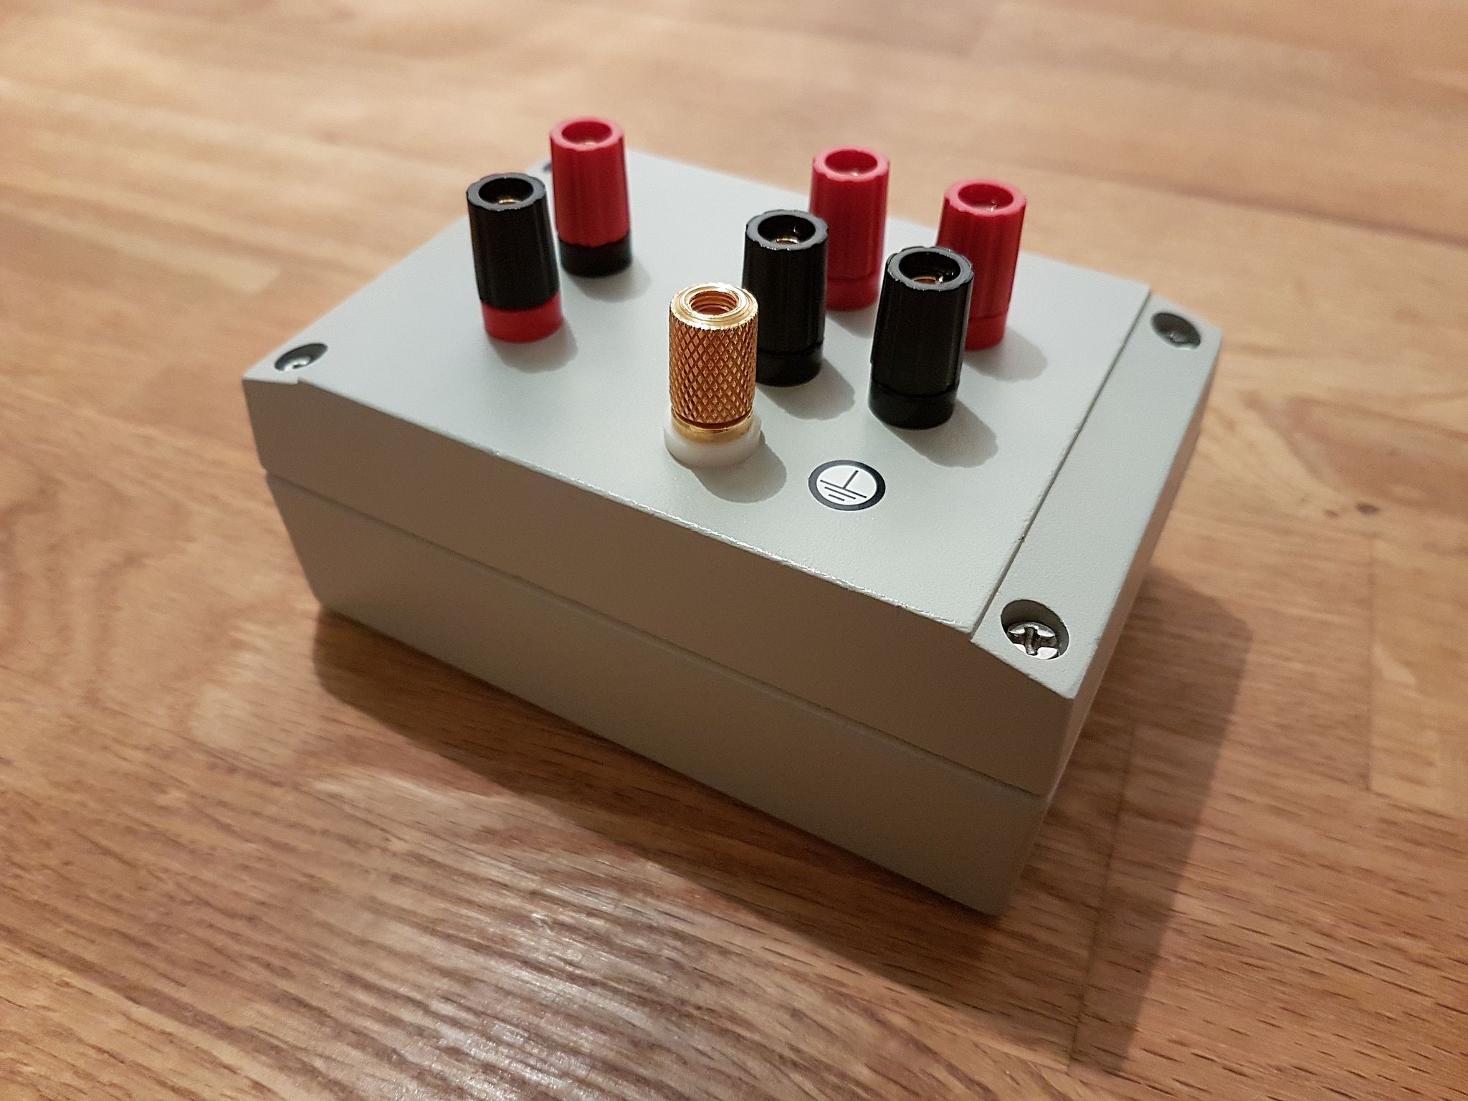Figure 13: The final reference resistor

References

[1] https://www.mouser.de/ProductDetail/Ohmite/HS520A10K00B?qs=ET3iBj0MToR%252BIZHZVcCIeQ%3D%3D

[2] http://bbs.38hot.net/thread-167995-1-1.html

[3] https://www.eevblog.com/forum/metrology/t-c-measurements-on-precision-resistors/?action=dlattach;attach=1374368

[4] https://de.farnell.com/rose/04-08-12-08/geh-use-industrie-grau-aluminium/dp/3874738

[5] https://xdevs.com/guide/teckit/

[6] https://github.com/tin-/teckit

